Test Project Module 1
(Corporate Design)
WSC2013_TP40_MO1_actual_EN

Submitted by:
Thierry Herman BE
Susanne Moustgaard DN
Terkko Malm FI
Sathish Narayanan IN
Amy Soon SG
Wolfgang Toechterle IT

Contents
This Test Project proposal consists of the following documentation/files:
(Este Projecto esta baseado nos seguintes documentos/arquivos)
- Text Doc (documento texto): WSC2013_TP40_MOD1_actual_EN
- WSC2013_TP40_MOD1_Folder containing: (arquivo WSC2013_TP40_MOD1_Folder contendo):
  - image files (arquivo de imagens): images
  - Font folder (Pasta da fonte): Kristall Now Pro
  - Given text in file (arquivo do texto fornecido): TEXT_Module_Corporate_Design.rtf
  - QR Code in file (arquivo do QR Code): druckkunst.png
  - Bag DieCut in file (arquivo do cortante da saqueta): BAG_dieCUT.ai
  - Colour profile file (arquivo do perfil de cores): ISOcoated_v2_300_eci.icc, ISOcoated_v2_300_eci.icc

Introduction (Introducao)
From the lead typeface to the Apple Mac:
550 years of printing history at the Museum of Printing Arts Leipzig
Da tipografia ao Apple Mac
550 anos da historia do Museum of Printing Arts Leipzig

The history of the “black art” is one of brilliant inventions, innovations rejected or developed and sudden radical change on a breathtaking scale. And yet it always remains a story about people. At the Leipzig Museum of Printing Arts, the human touch makes printing history come alive again: rare historical machines and printing presses are shown in action, enabling visitors to experience the art of printing with all their senses.
A Historia da “Arte Negra” ‘e uma das brilhantes invencoes, inivacoes rejeitadas ou desolvolvidas e que tiveram uma mudanca radical de cortar a respiracao. E ainda assim remete para a historia das pessoas. No “
Leipzig Museum of Printing Arts” o toque humano faz a historia da impressao continuar viva, maquinas raras e historicas e prensas de impressao sao paresentadas em accao, permitindo aos visitantes a experiencia da impressao em todos os sentidos.

The museum’s collection of around 100 working machines and press for historical casting, composing and printing techniques really brings the history of printing alive combining a museum and an active workshop, visitors still can experience printing process first hand. The Museum of Printing Arts also houses a handcraft book bindery, a workshop of a wood engraving and a unique collection of more than 4,000 different typefaces from European and oriental provenance. The Museum of Printing Arts is based in the former industrial quarter Plagwitz in a listed industrial building that has been in continuous use as a printing house since the early 20th century.

A colecao do museu possui cerca de 100 maquinas em plena funcao, composicao e tecnicas de impressao antigas fazem renascer a historia da impressao, combinando o museu e a oficina activa, os visitantes podem experimentar em primeira mao um processo de impressao. O Museum of Printing Arts tambem conta com uma encadernadora official, uma oficina de gravacao em madeira e uma colecao unica de mais de 4000 tipografias de origem europeia e oriental. O Museum of Printing Arts esta localizado no antigo bairro industrial Plagwitz, num edificio industrial protegido que foi utilizado como grafica desde o incio do seculo 20.

Three special exhibitions per year focus on individual theme related to printing and all its various facets. The current exhibition, which runs until mid-May 2012 is entitled “From lithography to offset printing, the Kunstanstalt Carl Garte Leipzig and the collection of Hans Garte”. It shows extraordinary examples of multi-colour lithography and early examples of offset printing from the beginning of the twentieth century.

Tres exposicoes especais por ano que focam temas especificos relativos a impressao e a todas as suas facetas. A exposicao atual, que ficara patente ate meados de maio de 2012, tem como titulo “Da Litografia a impressao offset, Kunstanstalt Carlo Garte Leipizig e a colecao de Hans Garte”. Esta exposicao mostra ao publico extraordinarios exemplos da litografia multi cor e de impressao offset do inicio do seculo XX.

The Museum sees the future as lying in intelligent networking of print and Internet along the lines of “Augmented Reality” – with the difference that all the senses are addressed simultaneously at the Museum. When it comes to the media mix of the future, the Museum recommends occasionally taking a look back at the history of printing technology so as to understand the here and now better and actively use expertise from the past as a source of inspiration for the future.

O museu antecipa que o futuro utiliza uma rede inteligente de impressao e internet juntamente com “realidade aumentada” – com uma diferenca, todos esses sentidos terao lugar ao mesmo tempo no museu. Quando o museu apresenta as novas tecnologias, recomenda que se observe o passado para que melhor se possa compreender o presente, utilizando a experiencia do passado como fonte de inspiracao para o futuro.

Description of project and tasks
Descricao do projeto e das tarefas

The Museum of Printing Arts needs to build an identity that will be used consistently through all its documents. Your job is to create this corporate identity; with colours, photos and illustrations, typefaces, etc. This will be applied to several promotional items including a Letterhead and Business Card, Entry Ticket and Shopping Bag.

O Museum of Printing Arts precisa construir uma identidade corporativa que sera utilizada em varios documentos. O teu trabalho ‘e criar uma identidade corporativa, com cores, fotos, ilustracoes, tipografias, etc. Essa identidade sera aplicada em varias pecas promocionais, incluindo papel de carta e cartoes de visita, bilhetes de entrada e sacos de compras.

Throughout the whole project you should consider that the museum represents the art of letterpress printing. Due to this, some documents will be produced with this printing method. When you design remember some of the limitations of letterpress printing. Such as fine lines, large solids and halftone screens or the transparent quality of letterpress Ink.

Enquato desenvolves o projecto, deves ter em mente que este museu representa a arte da impressao tipografica. Deves ter em conta que alguns dos documentos vao ser impressos com esse tipo de impressao. Quando criares o teu design, nao te esquecas de considerar as limitacoes desta tecnica de impressao, tais como: linhas muito finas, manchas muito grandes, meios tons, transparencias e a propria qualidade da impressao e da tinta.

Therefore the client asked for a clean and straight forward approach. The Design must be forward-looking and modern. Must explicitly be "not conservative."

Mesmo assim, o cliente deseja um estudo “clean” e moderno. O design deve ser de vaguarda e moderno. De uma forma muito clara, nao deve ser conservador.

Target audience
Publico alvo

Individuals and families who are interested in history of the “black art” and related brilliant inventions.
Individuos e familias interessadas em historia da black art e identificadas com invencoes geniais.

Task 1: logo
Tarefa 1: logo

The Museum of the Printing Arts needs you to create a logo for the Museum. The logo needs to embody the ideas of printing and all its various facets. From a historical, technical, handcraft view, up to the beginning of the twentieth century.
O “Museum of the Printing Arts” precisa que tu desenhes um logo novo. O logo deve transmitir o conceito de impressao nas suas mais variadas vertentes. Numa perspectiva historica, tecnica e artesanal ate o comeco do seculo XX.
- The logo should have a compact shape.
- A logo deve ter um formato compacto
- It should be possible to use it for both offset and letterpress printing.
- Deve ser possivel utiliza-lo tanto na impressao offset quanto na impressao tipografica
- The logo must include the complete name “Museum of Printing Arts Leipzig”.
- A logo deve conter o nome completo “Museum of Printing Arts Leipzig”.
- You must prepare the German version, too. “Museum für Druckkunst Leipzig”.
- Deves preparar uma versao alema tambem “Museum für Druckkunst Leipzig”.
This version of the logo is the same design. This logo will be used in all the German language documents.
- A versao Alema e Inglesa devem ter o mesmo design
The city name "Leipzig" is an important part of the Logo because of the existence of other similar museums in other cities.
- O nome da cidade "Leipzig" e parte importante do logo porque que ha outros museus noutras cidades com o mesmo nome

Technical specifications:
Especificacoes tecnicas

Colours: Two versions of the same logo: a) 2 PMS colour b) CMYK
Cores – duas versoes do mesmo logo: a) 2 cores PMS b) CMYK

Include the name of the Pantone number with a colour swatch.
Faca uma legenda das cores Pantone que voce utilizou

Text for two separate logos with the same design: English Logo: Museum of Printing Arts Leipzig
German Logo: Museum für Druckkunst Leipzig
Texto para os dois logos com o texto diferente e com o mesmo design -
Logo ingles - Museum of Printing Arts Leipzig
Logo alemao - Museum für Druckkunst Leipzig

Printing: Letterpress and offset printing
Impressao – impressao tipografica e impressao offset

Trapping: 0.5 points
Trapping – 0.5 pontos

Images: Only vectorized images are allowed for the logo
Imagens – somente imagens vetoriais sao permitidas

You must deliver:
Voce deve entregar:

- 1 final folder of your working files for archiving
- 1 pasta final com seus arquivos de trabalho

- 1 Illustrator (ai) file showing the English and the German logo in 2 PMS colours (Pantone Uncoated), as well as the English and the German logo in CMYK on the same Artboard (All 4 on same page)
- 1 arquivo Ilustrator com quatro logos: 1 versao Ingles PANTONE, 1 versao Alemao PANTONE, 1 versao Ingles CMYK, 1 versao Alemao CMYK – todos na mesma pagina A4

- 1 PDF/X-3:2002 file of your logo in CMYK (NO SPOT COLOUR INCLUDED)
- 1 arquivo PDF/X-3:2002 com o teu logo em CMYK (nao pode haver cores directas)

- 1 A4 printout, mounted on presentation board showing the two versions of the Logo (English and German) as well as the two colour Versions (PMS and CMYK). Display the used colour swatches in a colour chart.
- 1 copia impressa, montada numa prancha de apresentacao com as duas versoes da logo (ingles e alemao) bem como com as duas versoes de cores (PMS e CMYK) de ambos os logos. Coloca uma legenda das cores utilizadas.

Task 2: Letterhead and Business Card
Tarefa 2 / papel carta e cartao de visitas

Required elements for both – letterhead and business card:
Elementos obrigatorios para os dois – papel carta e cartao de visita:

Given text:
(texto fornecido)

Stiftung Werkstattmuseum für Druckkunst
Nonnenstraße 38
D-04229 Leipzig
Tel. +49 341 / 231 62-0
Fax +49 341 / 231 62-10
info@druckkunst-museum.de
www.druckkunst-museum.de

Logo: German version only (somente a versao alema)

Font: The museum owns the font family Kristall Grotesk. This font family must be used for the entire “given text” on the letterhead and business card.
Fonte – O museu possui a fonte da familia Kristall Grotesk. Essa familia de fonte deve ser utilizada para todo o texto fornecido, tanto no papel carta e quanto no cartao de visita

Technical specifications LETTERHEAD:
(Especificacoes tecnicas PAPEL DE CARTA)
Colours (cores): CMYK
Trim size (marca de corte); A4 (297 X 210 mm)
Printing (Impressao): offset printing
Bleed (sangra): 3 mm
ICC profile (perfil ICC): PSO_Uncoated_ISO12647_eci.icc
Greyscale and colour images resolution: Only vectorized images are allowed for the letterhead
Resolucao das imagens pb e cores – somente imagens vetoriais sao permitidas no papel carta

Technical specifications Business Card:
(Especificacoes tecnicas do CARTAO DE VISITA)
Trim size business card (tamanho final do cartao de visitas): 85 x 55 or 55 x 85 mm

Design: Both side (front and back) Ambos os lados (frente e verso)
Printing (impressao): Letterpress
Colours (cores): 2 spot colours (duas cores especiais)
Bleed (sangra): 3 mm
Trapping (Trapping): 0.5 points

ICC profile (Perfil ICC): PSO_Uncoated_ISO12647_eci.icc
Bitmap, grayscale and colour image resolution: Only vectorized images are allowed for the Business Card
Resolucao das imagens pb e cores – somente imagens vetoriais sao permitidas no papel carta

You must deliver:
Deves entregar:
- 1 Letterhead final composite PDF/X-3:2002 file (including bleed, crop marks and specified output profile)
- 1 arquivo final do papel carta em PDF/X-3:2002 (incluindo sangra, marcas de corte e o perfil ICC pedido nessa tarefa)
- 1 Business Card final composite PDF/X-3:2002 file (including bleed, crop marks and specified output profile)
- 1 arquivo final do cartao de visita em PDF/X-3:2002 (incluindo sangra, marcas de corte e o perfil ICC pedido nessa tarefa)
- The letterhead and business card trimmed and mounted onto a single presentation board.
- O Papel carta e o Cartao de visita cortados e montados numa prancha de apresentacao
- 1 A4 printout of your Business Card (front and back) with ONLY crop marks and bleed marks
- 1 copia impressa em A4 do cartao de visita (frente e verso) APENAS com as marcas de corte e de sangra
- 1 A3 printout of your Letterhead with ONLY crop marks and bleed marks
- 1 copia impressa em A3 do papel carta APENAS com as marcas de corte e de sangra
- 2 final folders for archiving and printing (including PDF, native files, fonts,)
- 2 pastas finais para arquivo e impressao (incluindo PDF, arquivos nativos e fontes)

Task 3: Entry Ticket
Tarefa 3: Bilhete de Entrada

Create a one colour, one-sided entry ticket to be given at the entrance to all visitors. The client would like to show a consistent design throughout all documents. Tradition and modernity are important. The given serial number needs to be included in part 1 and part 2 of the ticket.

Desenha com uma unica cor e de um unico lado, um bilhete que sera entregue na entrada para todos os visitantes. O cliente gostaria de apresentar um design coerente entre todos os documentos. Tradicao e modernidade sao importantes. Os numeros de serie fornecidos precisam ser incluidos nas partes 1 e 2 do ticket.

Required elements
(Elementos obrigatorios)

Given text :
(Texto fornecido)
Between technology and art
Experience type casting, type setting
and printing processes in a working museum
Nonnenstrasse 38, D- 04229 Leipzig
Phone +49 (0) 341-231 62 0
www.druckkunst-museum.de
Mon - Fri 10 -17, Sun 11 -17, closed Saturday

Serial number use (numero seriado utilizado): 247398

Logo: English version only (1 PMS colour)
Logo: versao em ingles (apenas 1 cor PMS)
Design: Single sided
Design: apenas de um lado

Font: no specification
Fonte – sem especificacao
Serial number: To be on both parts of the ticket (on part 1 and part 2)
Numero de serie – deve constar das duas partes do ticket (na parte 1 e na parte 2)

QR-Code:
minimum size: 20 x 20 mm, must be 100% colour
Tamanho minimo – 20 x 20 mm, deve estar a 100% da cor

File: druckkunst.png


Technical specifications:
(Especificacoes tecnicas)
Printing: Letterpress
Impressao: tipografica
Colours: 1 PMS colour. Use Pantone uncoated numbers.
Cores – 1 cor PMS Uncoated.
Bleed: 3 mm if needed
Sangra – 3mm se necessario
ICC profile: PSO_Uncoated_ISO12647_eci.icc
Perfil ICC: PSO_Uncoated_ISO12647_eci.icc
Trim size: 150 x 60 mm
Tamanho final: 150 x 60 mm
Perforation: to be indicated with a straight vertical line 45 mm from the left
Perfuracao – a ser indicada por uma linha reta vertical a 45mm da esquerda
Images resolution: Only vectorized images are allowed for the Entry Ticket
Resolucao das imagens – somente imagens vetoriais sao permitidas no bilhete
45 mm ---->
Part 2
Part 1

You must deliver:
Deves entregar:
- 1 final composite PDF/X-4:2010 file (including: bleed, crop marks, and specified output profile). The perforation and serial number must be placed on a separate layer in the PDF file.
- 1 arquivo final PDF/X-4:2010 (incluindo: sangra, marcas de corte e perfil ICC especificado para esta tarefa). A perfuracao e o numero seriado devem ser colocados num layer separados no arquivo PDF)
- 1 printout of your composition trimmed and mounted on 1 A4 board to present your design.
- 1 copia impressa de sua composicao cortada e montada numa prancha A4 para apresentar seu design.
- 1 A4 printout of your Ticket with ONLY crop marks and bleed marks
- 1 impressao A4 de seu ticket somente com as marcas de corte e de sangria
- 1 final folder for archiving and printing (including PDF, native files, fonts)
- 1 pasta final para arquivamento e impressao (incluindo PDF, arquivos nativos e fontes)

Task 4: Shopping Bag
Tarefa 4: Saco de Compras
Create a full colour (CMYK), two-sided shopping bag for the museum shop. It’s a redesign of an existing bag therefore, the size of the bag and die cuts are given. Due to the many international visitors the German and the English Logo version must be represented on the bag. The customer requires you to use a spot varnish on both versions of the Logo.

Crie um saco com impressao dois lados em CMYK para a loja do museu. E’ um redesign de um saco que ja existente portanto, o tamanho e o cortante do saco ja estao definidos. Como muitos dos visitantes sao estrangeiros, as versoes em alemao e ingles do logo devem estar representadas na sacola. O cliente lhe pede que utilize verniz em ambos os logos, usa uma cor spot para representar o verniz.

Required elements
Elementos Obrigatoris

Given text:
(Texto fornecido)
Between technology and art
www.druckkunst-museum.de

Logo: Both English and German Version with spot Varnish

The indication of the varnish must be named as “Varnish”, as a spot colour and it must be 100% black

Logo: ambas as versoes, em ingles e em alemao, com uma cor especial para o verniz
A indicacao do verniz deve ser nomeada como “Varnish”, com uma cor especial e deve ser 100% preto

Font: no specification
Fonte: sem especificacao

Images: Minimum 2 images must be used, you are free to use more.
Imagens: no minimo duas imagens devem ser utilizadas, se quizeres podes usar mais.

DieCut: You must use the given Die Cut “BAG_dieCUT.ai”. An example of the printed bag will be given to each competitor.

Cortante: Deves utilizar o cortante fornecido “BAG_dieCUT.ai”. Um exemplo impresso da sacola sera fornecida para cada competidor

Technical specifications:
(Especificacoes tecnicas)
Printing (impressao): offset
Colour: CMYK + spot varnish (Cor: CMYK + cor especial para o verniz)
Bleed (sangra): 3 mm
Trapping: 0.5 points
ICC profiles (Perfil ICC): ISOcoated_v2_300_eci.icc

Trim size: design on the given Die Cut. (Corte final: baseado no cortante fornecido)
Greyscale and colour image resolution: 262 to 350 PPI at 100% in the design (Layout)
Resolucao de imagens a cores e a pb: 262 a 350 PPI a 100% no design (layout)
Bitmap image resolution: 800 to 1200 PPI at 100% in the design (Layout)
Resolucao de imagens bitmap: 800 a 1200 PPI a 100% no design (layout)

You must deliver

Deves entregar:
- 1 final composite PDF/X-3:2002 file (including bleed, die cut and specified output profile, colour bars for CMYK + varnish at 100% black)
- 1 arquivo final em PDF/X-3:2002 (incluindo sangra, cortante e perfil ICC especificado para essa tarefa, barra de cores para o CMYK e o verniz a 100% preto)
- 1 printout of your composition to fit on A3 with the varnish on top of the design (the varnish area needs to be 20% transparency)
- 1 impressao da composicao final que caiba no A3 com verniz aplicado sobre o design (a area do verniz precisa ter 20% de transparencia)
- 1 printout of your composition to fit on A3 and mounted on one board for presentation without the varnish.
- 1 impressao da composicao final que caiba no A3, montada na prancha de apresentacao sem verniz
- 1 final folder for archiving and printing (including PDF, native files, fonts, linked images, ICC profile)
- 1 pasta final para arquivo e impressao (incluindo PDF, arquivos nativos, fonts, imagens relacionadas, perfil ICC)

Instructions to the competitor (Instrucoes para o competidor)
About image marking for all tasks
(Sobre a avaliacao das imagens em todas as tarefas):
The final resolution, colour mode and file formats of your images will be evaluated in the press ready PDF files. The JPG file format is NOT ACCEPTED for images files (outside of the PDF); only the following saving format files are acceptable: .tif / .eps / .ai / .png

A resolucao final, producao da cor e os formatos de arquivo de suas imagens serao avaliados nos arquivos press ready PDF. O formato de arquivo JPG NAO E ACEITE como arquivo de imagens (fora do PDF). Somente os seguintes formatos de arquivos serao aceites: .tif / .eps / .ai / .png

Create a folder on your Desktop called YY_MOD_X (where YY represents the number of your workstation and X your Last Name). This folder must include the following subfolders “Task1, Task2, Task3, Task4”. Those subfolders contain two folder with:

Crie uma pasta no seu Desktop chamada YY_MOD_X (onde YY significa o numero de sua estacao de trabalho e X o seu sobrenome). Esta pasta deve incluir as seguintes subpastas: “Tarefa 1, Tarefa 2, Tarefa 3, Tarefa 4”). Cada uma destas subpastas contem duas pastas com:

- Original folder: it should contain all the files used for the development of your project, properly organized (fonts, links, etc.).
- “Original Folder”: ela devera conter todos os arquivos utilizados para o desenvolvimento do teu projeto e estar devidamente organizada (fontes, linkes, etc)
- Final folder: it should contain all the files you are supposed to deliver to print as required in the tasks (PDF, etc.).
- “Final folder”: ela devera conter todos os arquivos que voce devera entregar, tal como solicitada nas tarefas (PDF, etc)

Any file saved out of its respective folder WILL NOT BE EVALUATED.
Qualquer outro arquivo salvo fora da sua pasta respectiva NAO SERA AVALIADO.

Images must not be embedded in Adobe Illustrator or InDesign

As imagens nao poderao estar embutidas no Adobe Illustrator ou InDesign

The colour mode and file formats of your images will be evaluated in the press ready PDF files; EXCEPT in Task 4 Greyscale and colour image resolution will be evaluated in the used software such as InDesign or Illustrator.

Os modos de cor e os formatos dos arquivos das tuas imagens serao avaliados nos arquivos PDF press ready; COM EXCECAO da tarefa 4, onde o modo de cor e resolucao das imagens a cores e pb serao avaliadas no softaware utilizado, tal como InDesign ou Illustrator.

Equipment, machinery, installations and materials required

equipamentos, maquinariA, instalacoes e material requeridos
No specific equipment required. (Nenhuma especificacao de equipamento e requerida)

Marking scheme (Esquema de avaliacao)
A2 |  |  | 2,00
 | Ideas and originality | 1,00
 | Understanding the target market | 0,50
 | Unity and relationship between all tasks | 0,50
B2 |  |  | 8,00
 | Logo inline with clients brief | 1,00
 | Quality of the visual composition of the Logo (aesthetic appeal and balance) | 1,50
 | Visual Impact & Communication effectiveness (Letterhead and Business Card) | 1,00
 | Visual Impact & Communication effectiveness (Ticket Design) | 0,50
 | Visual Impact & Communication effectiveness (Shopping Bag Design) | 1,00
 | Quality of the typography for all tasks | 1,00
 | Quality of the colours for all tasks | 1,00
 | Quality of the mounted presentations and the printouts | 1,00
C2 |  |  | 4,00
 | Resolution of images in Layout as specified in T1, T2, T3, T4 | 0,75
 | Colour mode of the Logo as specified in all tasks | 0,75
 | Image or element dimensions as specified | 0,75
 | Final dimensions of layout as specified in task 2 and 3 | 0,50
 | All required text is present in all task | 0,50
 | All required elements are present in task 2, 3 and 4 | 0,75
D2 |  |  | 2,00
 | Mounting printouts on board for presentation | 1,00
 | Supply of printouts all tasks | 1,00
E2 |  |  | 4,00
 | Bleed value applied in PDF as specified in the task | 0,75
 | Trapping value applied in the file as specified in the task | 0,75
 | Overprinting applied in PDF as specified in the task | 0,50
 | Spot and CMYK colours used in PDF file as specified in the T1,T2,T3 | 1,00
 | Color, varnish and dieCut in PDF as specified in task 4 | 0,50
 | Naming of spot colour PMS U in T1, T2 and "Varnish" in task 4 | 0,50
F2 |  |  | 5,00
 | Correct naming and all files saved in the correct format specified in the task | 1,25
 | ICC profile applied in PDF file as specified in the task | 1,25
 | Saving in a specified PDF format as required in the task | 1,50
 | Final production folder saved as required in the task | 1,00

Total = 25 marks per module (Objective 15 + Subjective 10)

APPENDICES
Text
Images
QR-Code
Preview Shopper model
DieCut

Task 1: logo

Museum of Printing Arts Leipzig
Museum für Druckkunst Leipzig

Task 2: Letterhead and Business Card

Stiftung Werkstattmuseum für Druckkunst
Nonnenstraße 38
D-04229 Leipzig
Tel. +49 341 / 231 62-0
Fax +49 341 / 231 62-10
info@druckkunst-museum.de
www.druckkunst-museum.de

Task 3: Entry Ticket

Between technology and art
Experience type casting, type setting
and printing processes in a working museum
Nonnenstrasse 38, D- 04229 Leipzig
Phone +49 (0) 341-231 62 0
www.druckkunst-museum.de
Mon - Fri 10 -17, Sun 11 -17, closed Saturday

Task 4: Shopping Bag
Between technology and art
www.druckkunst-museum.de

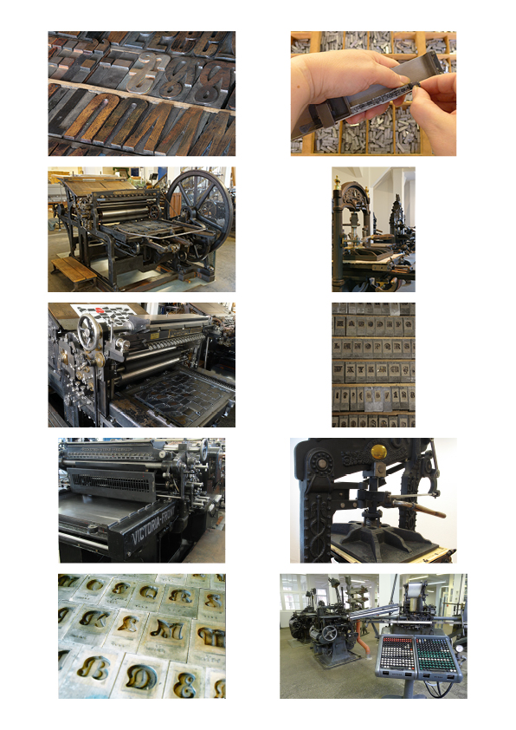
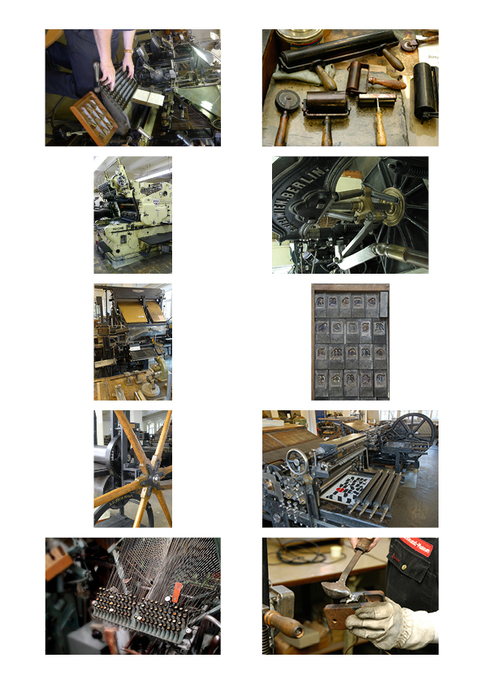
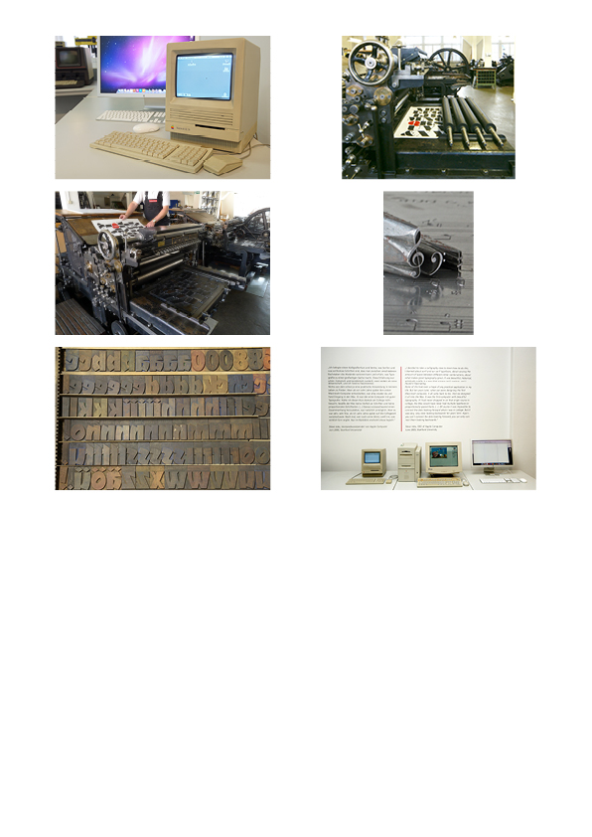



QR-Code: minimum size: 20 x 20 mm
File: druckkunst.png

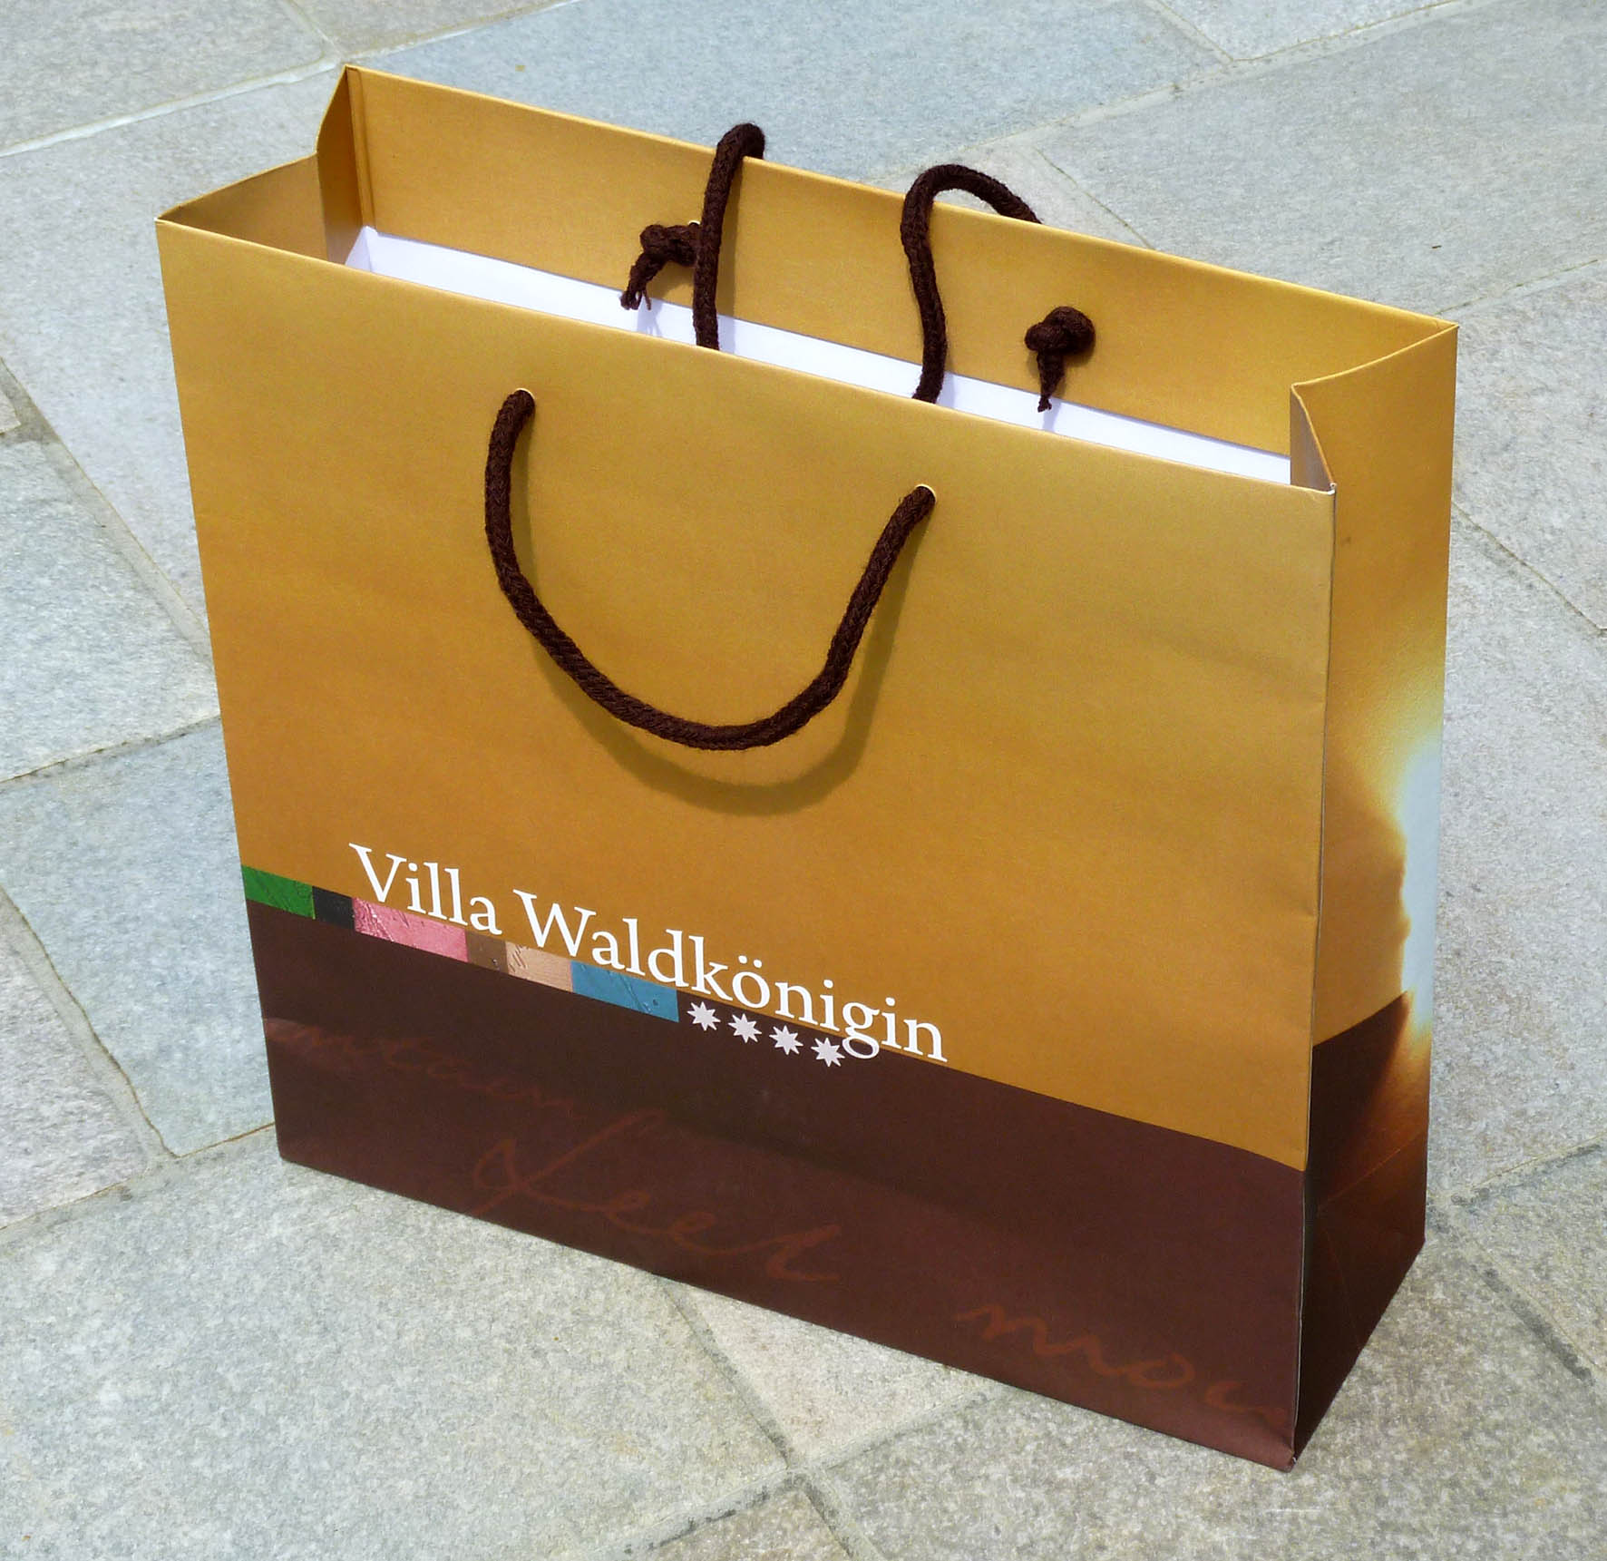

Example of a shopping bag with the given DieCut

given DieCut

